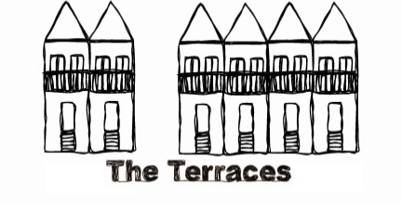
St Barnabas Terraces’ Application Form

Office Use only:
Registration Paid
________________________
Receipt sent
Interview time
________________________
Offer made
Accepted
Bond Paid
________________________
Rent in Adv. Paid
________________________
Move-In Date
________________________
Resident #
Surname:
Attach scanned photo here or photo will be pasted here when received
First name(s):
Nickname / preferred name:
Date of birth:
Gender:
Mobile phone number:
Home phone number:
Email:
Address 1: (your family address)

Suburb: State: Postcode:
Address 2: (if different from above)
Suburb: State: Postcode:

What are you doing this year?

When and where did you do your HSC? (year and school)

What do you intend to study as a full time undergraduate student?

At what institution?

What year of study will you be in?

Note: The Terraces has a one week move in period in mid-February. Specific dates will be supplied at interview
Details of a relative or friend in Sydney: (who could be contacted in an emergency?)
Name:
Address:
Phone number:
Relationship:

Details of your next of kin: (to be notified in case of serious illness or accident)
Name:
Address:
Phone number: (please include country and area codes)
Relationship:

Details of a referee:
Name:
Address:
Phone number: (please include country and area codes)
Relationship:
When are you available to come for an interview? (please circle/highlight)
(Please note we do not offer telephone or skype interviews. All applicants wishing to be considered for a place must be willing to attend a face-to-face interview in Glebe)

Late Oct/ November/ early Dec late January / early February (second round offers) No preference
Are there any dates around these times when you are unavailable?

What are your reasons for wanting to live at St Barnabas Terraces?

Have you lived out of home before?
No
Yes - please provide a detailed history

How did you hear about St Barnabas Terraces?
A friend (name) A relative (name)
Terraces’ website University accommodation service (incl website) Other (please specify)
Are you under medical supervision of any kind?
No
Yes - please provide details

What do you consider your strengths to be?

What do you see as your weaknesses?

In approx. 150 words, please write about yourself – your interests, goals, family, character etc

Checklist:
I understand and am willing to abide by the St Barnabas Terraces Rules and Internet User agreement.
I have attached one digital photo of myself or I am mailing two passport sized photos
I would like to pay the $50 AUD application fee by:
Cash (please mail to the address below along with this Application Form)
Credit Card (please complete details below or contact the office to pay over the phone)
Type of card:
Name on card:
Expiry date:
CCV:
Card Number:

Please return this competed form by email to office@terraces.com.au
or post to the following address : The Supervisor
St Barnabas Terraces
PO Box 606
Glebe NSW 2037
Australia

Once your application is received and processed the Terraces Office will email or phone you to set up a time for a face to face interview.

